

Computer Systems
CFGS DAW

UNIT 3.Hardware components
Internal components

Alfredo Oltra / Sergio Garcia
alfredo.oltra@ceedcv.es
sergio.garcia@ceedcv.es
2019/2020
Versión:190919.0951

Licencia

Reconocimiento – NoComercial – CompartirIgual (by-nc-sa): No se permite un uso comercial de la obra original ni de las posibles obras derivadas, la distribución de las cuales se debe hacer con una licencia igual a la que regula la obra original.

Nomenclatura

A lo largo de este tema se utilizarán distintos símbolos para distinguir elementos importantes dentro del contenido. Estos símbolos son:

◻ Importante

 Atención

 Interesante

Índice de contenido
1. Motherboard 4
1.1 Form factor 4
1.1.1 Reduced formats 6
1.2 Jumpers 7
1.3 BIOS 7
1.4 UEFI 8
1.4.1 The boot problem 8
1.5 Connectors 9
1.5.1 Internal 9
1.5.2 External 9
1.6 Expansion slots 10
1.7 Socket 11
2. Chipset 11
2.1 Northbridge 12
2.2 Southbridge 12
2.3 Trade names 12
2.4 Northbridge – Southbridge connection 12
2.5 Block diagram 13
3. Processors 13
3.1 Internal architecture 13
3.1.1 Single Core 13
3.1.2 Multi core 14
3.2 Features 15
3.2.1 Frequency 15
3.2.2 Bus speed 15
3.2.3 Cache 16
3.2.4 32 and 64 bits 17
4. Memory 17
4.1 Computer memory system 17
4.2 Memory controller 18
4.3 Bus memory 18
4.4 Features 18
4.4.1 Clock speed 18
4.5 Bandwidth 18
4.6 Number of channels 19
4.7 RAM types 19
4.8 Memory modules 20
4.8.1 SIMM and DIMM modules 20
4.8.2 Laptops modules 20
4.8.3 Unbuffered and registered modules 20
4.8.4 Parity modules and ECC modules 21
5. Additional material 21
6. Bibliography 21

UD03. Hardware components
Internal components

Motherboard
The motherboard, also known as MoBo, is a printed circuit board where the computer components are connected. It tends to give more Importance to other elements such as the microprocessor or memory, but the motherboard is critical: what and how many components can be installed in the computer depends on it.

 At first, each MoBo could hold a specific model of processor (CPU) but from any manufacturer (Intel, AMD, Cyrix..). But since 2004, although the processors were compatible in functionalities, manufacturers were differentiating their models in the pinout, so the motherboard has to be specific to each type of processor ever since.

It has installed a series of integrated circuits, including the chipset which serves as a hub between the microprocessor, random access memory (RAM), expansion slots and other devices. All the components of the motherboard are connected with “paths” whose name is buses.
Besides, the motherboard includes a firmware (software stored in a read-only memory like EEPROM, flash...) called BIOS, which lets you perform basic functions such as testing devices, video and keyboard operations, recognition devices and operating system load.

Form factor
A personal computer is made up of several independent elements. For example, motherboard, casing, power supply, etc. Each of these components is provided by a separate manufacturer. If there were no minimum agreement between manufacturers, it would not be possible interoperability of these components. For example, a motherboard could not physically enter into the casing, or a power supply plug could be incompatible with the connector on the motherboard. One of these agreement, it's a standard called form factor.
The features that define one form factor are:
- The shape of the motherboard: square or rectangular.
- Their exact physical dimensions: width and length.
- The position of the anchors. That is, the coordinates where the screws are positioned to anchor it to the casing.
- The areas where certain components are located. Specifically, the expansion slots and the rear connectors (keyboard, mouse, USB, etc.)
- The electrical connections of the power supply, that is, the number of power supply wires that the motherboard requires, their voltages and function.
As you can see from the table below, there are many form factors, and many more that are appearing with new devices such as tablets and phones.
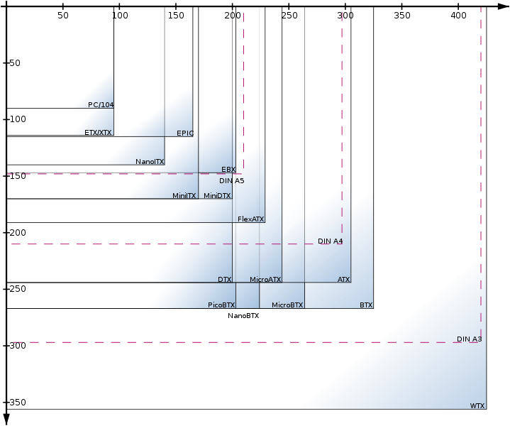Figure 1. Comparative table of several form factors
Among all form factors, perhaps the ATX and its variants are the best known. Its name comes from AT eXtended, because it replace the former AT form factor, adding several features to improve its functionality:
- Dimensions: 305x244mm
- A connector for the power supply which prevents incorrect connection.
- The connectors are laid out better to reduce cable length.
- It improves the components layout rotating the motherboard 90º and placing the CPU and memory near the fan power supply and away from expansion cards (thus allowing the connection of larger cards)
- A connection and disconnection system of the computer through software.

 Although it seems strange, not too many years ago, it was impossible to turn off the computer from the Operative System (OS). The computer turned off like a light bulb, with a switch.

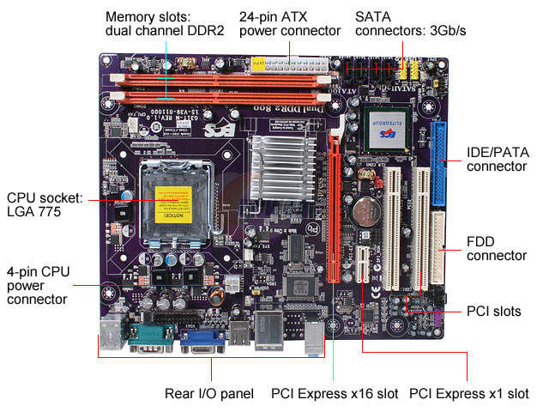

Figure 2. ATX form format

Reduced formats

A lot of form factors have their smaller size versions. Today most users hardly use expansion cards due to elements such as sound and network cards are integrated into the motherboard. Therefore, removing the expansion slots to gradually reduce the size makes sense.
One of the small format that is most successful is the Mini-ITX (170x170 mm), which typically includes at least one expansion card and many embedded devices.
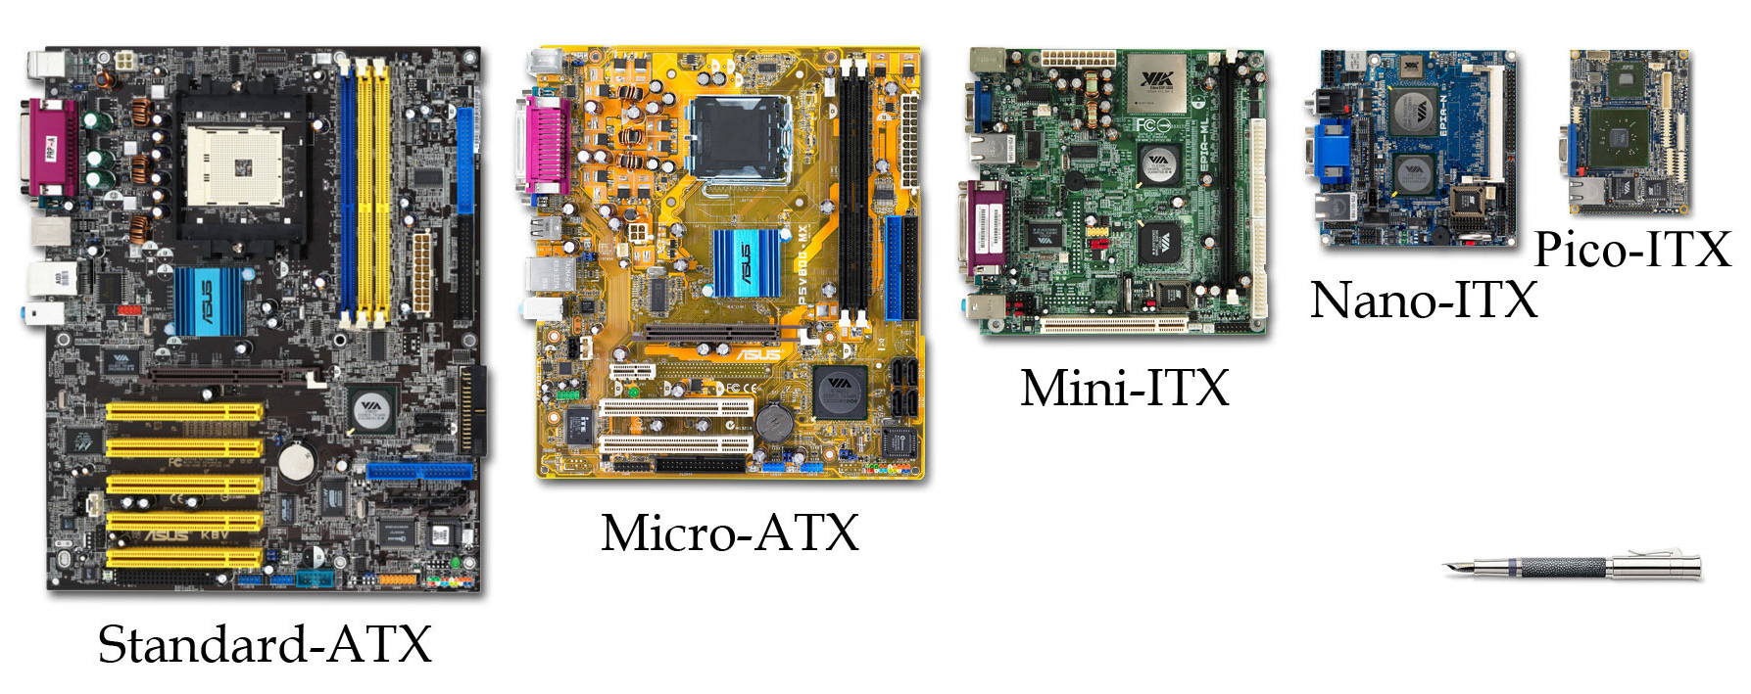
Figure 3. Comparative motherboard

Jumpers
Used to configure some elements of the motherboard. The motherboard manuals show diagrams about the configuration options. They tend to disappear because, lately, everything is configured from the SETUP.

BIOS
The BIOS (Basic Input Output System) is the basic computer software for controlling the hardware elements.
◻ A common mistake is to think that the BIOS is a hardware component. It is software. In fact, is not a single program. It s a set of programs that perform different tasks.
One of the most important programs is POST. It runs when you turn on the computer and locates and recognizes all devices needed to load the operating system into RAM. It manages at least the computer keyboard, and provides a basic output in the form of sounds trough the motherboard speaker when there is an error, such as a device failure or an error in the connection. These error messages are used by technicians to find solutions when assemble or repair the computer.
Formerly, it was stored in a chip ROM (Read Only Memory), a memory that can only be read, and not deleted if it lacks the power. So, if you wanted to change the program you had to change the whole chip which, obviously it was a very complicated task. Today, it is installed on a Flash or EPROM chip memory, which allows updating, although in a complicated and delicate way. All models used (ROM, EPROM or Flash) are slower than conventional RAM, therefore the execution of BIOS programs usually slow.
Another well-known program of the BIOS is the SETUP. This program provides a graphical interface that allows access to another memory, CMOS, where part of the system settings are saved. CMOS is not a ROM, so it needs power to save the data. For that, the motherboard has a battery. If the battery runs out, all settings are lost and we need to change the battery and configure the system again.
 When the battery runs out, the POST program detects it and sends a warning by a beep and a message on the screen, stopping the boot up and asking the user if he wants to reconfigure the system or work with default values.
How we can locate the chip where the BIOS is on the motherboard? They usually have a label (sticker) on top indicating the version and manufacturer.
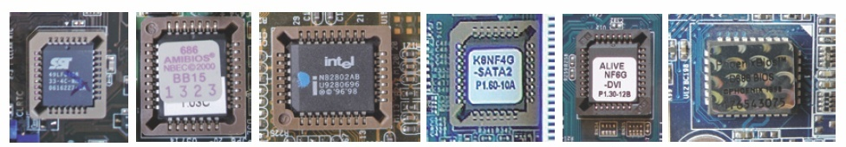Figure 4. Different BIOS
◻ Remember: Do not confuse the CMOS with BIOS, or the BIOS with setup.

UEFI
Although BIOS is an effective system, it has lost in efficiency over the years, so the industry needed to evolve it. That is why in recent years the BIOS has been replaced by UEFI.
UEFi's main idea is to replace the BIOS by adding new features such as a setup with a much more modern graphical interface, a secure boot system, a higher boot speed or support for hard disks over 2TB.

The boot problem
Sequentially speaking, the last process that the BIOS or UEFI has to do is to boot the OS (or a launcher that allows you to boot one OS among several). In UEFI, a secure mode has been implemented, to prevent the execution of any software not signed and certified by the manufacturer (mainly intended to prevent virus infection in the boot system). So for example Windows 8 required the secure mode to be able to install, but at the same time, this mode avoids the install another operating system like any Linux distro or other Windows family OS (like Windows 7). Besides, in UEFI we can only install 64 bit systems.
To solve these problems, the most UEFI include the possibility to switch between UEFI mode and legacy mode (BIOS mode).
It is a good idea to choose the UEFI operating mode before starting to install the operating systems. A change made halfway through the process can not only cause already installed operating systems to stop working, but can also result in data loss.

◻ Using UEFI or legacy mode has other implications that we will see in next units. For example, BIOS mode uses an MBR hard disk partition system, while UEFI uses GPT. Switching between them results in data loss.

Connectors

Internal
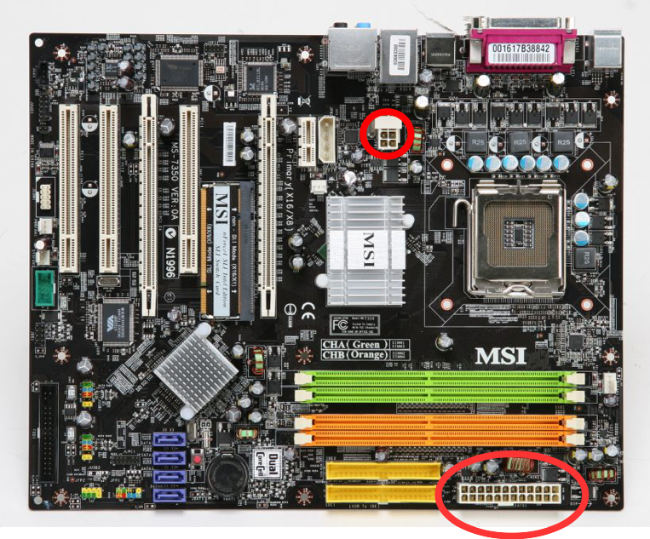Figure 5. ATX 2.2 connectors
Power supply. Also called MOLEX connector. The power supply model that can be used is defined in terms of the number of pins. There are 3 models:
ATX: 20 pins
ATX 2: 24 pins
ATX 2.2 : 24 + 4 pins
Versions 2 and 2.2 are very similar. Both of them have one connector with 20 pins, but 2.2 version besides has another with 4 pins

Front panel and speaker. They connect casing elements, such as different LED's or the internal speaker to the motherboard. They usually have written on the connector which is its function.
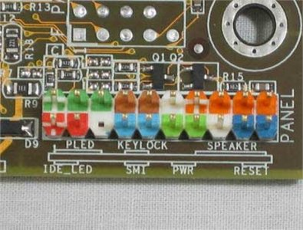
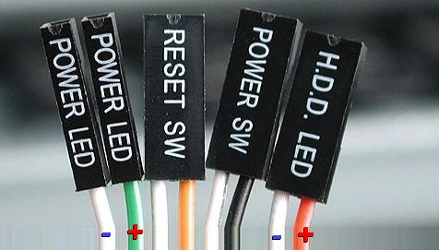
Figure 6. Front panel connector

External
Keyboard and mouse. Connectors for keyboard and mouse are special and are called mini-DIN. They are placed together. The keyboard is violet and green mouse.
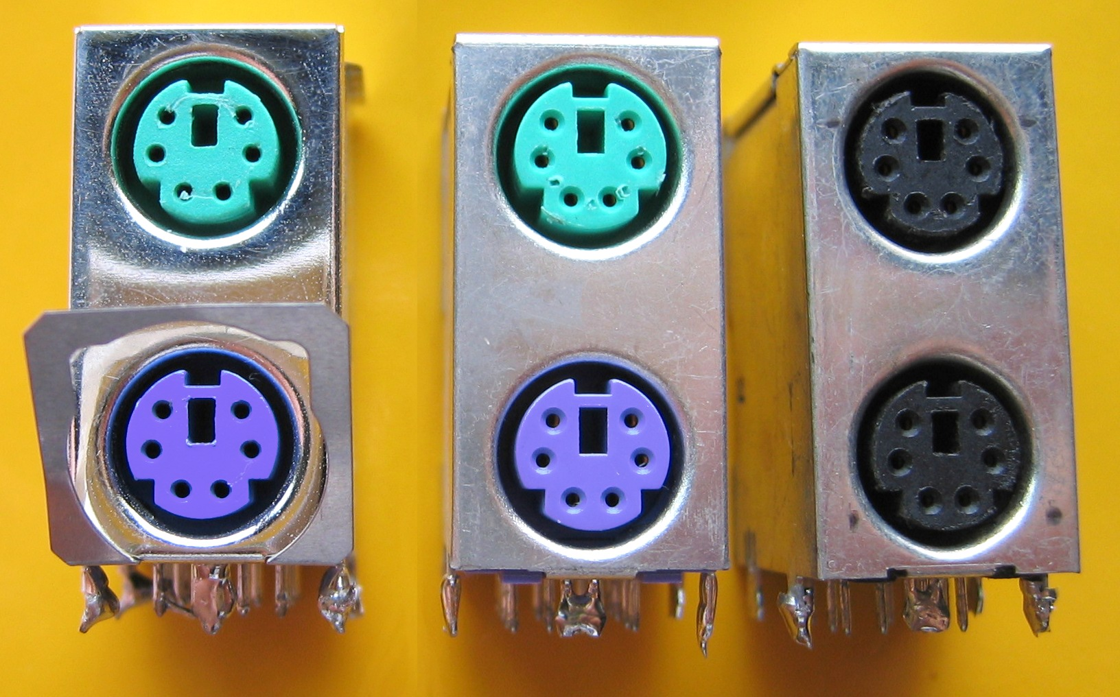Figure 8. miniDIN
Today most keyboards and mice are connected by USB. But it is highly recommended to have miniDIN keyboards because they allow us work when we have problems with USB ports.
 If they are not connected when the computer is turned on, they will not be recognized. This does not happen in the USB.
Parallel and serial port. There are two ways to send or receive data between computer components: parallel and serial. In the serial way, information is transferred in or out one bit at a time, while in the parallel way the information is transferred in groups (generally power of 2) at the same time.
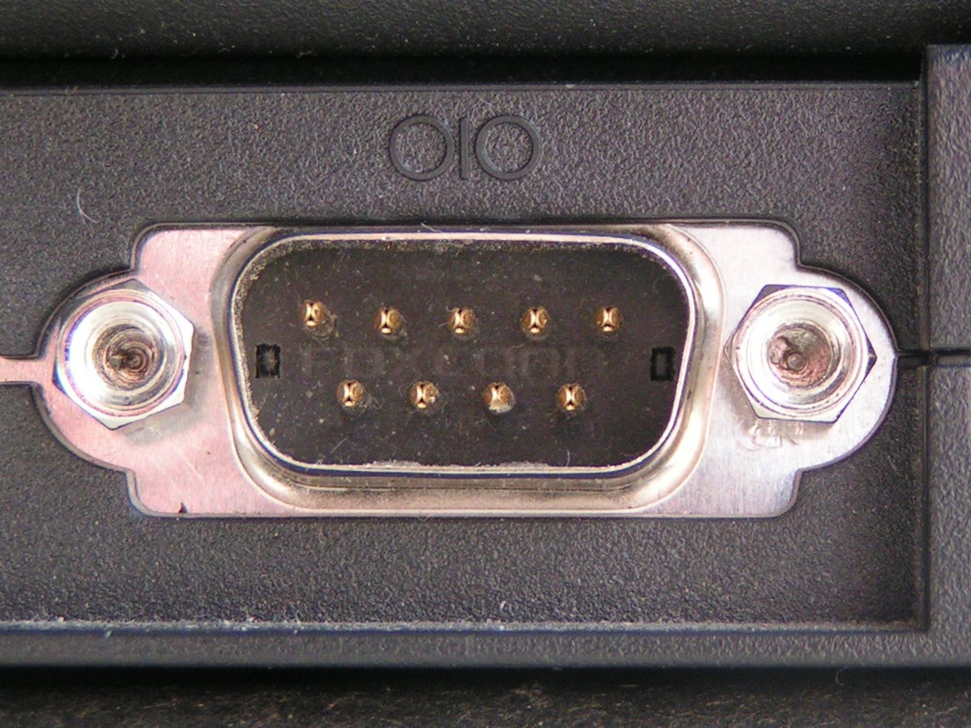Figure 9. Serial port
The motherboard has ports, connectors where we can connect external elements. Obviously, there are two types: parallel (also called Centronics) and serial (also called RS-232 or COM).

 A very common mistake is to confuse the serial port with the VGA port. In the motherboard, serial port is a male connector, while the VGA port is female port. Be careful!.
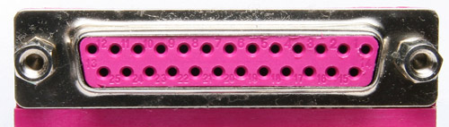Figure 10. Parallel port
USB. Universal Serial Bus. It is a serial connector that improves the characteristics of the old serial ports. It reaches 12 Mb/s and up to 4.8 Gb/s in the 3.0 version.
It is possible, through hubs, distribute the signals and create more ports. But in this case the speed available is divided up among all the connected elements to the hub.
The boards have usually two or three hubs and each of them usually get two or three connectors on the casing. For example, the two front connectors belong to the same hub, so if we connect two high speed peripherals to the front connectors, can have problems.
 In fact, the problem is worse. In general, the hub adapts the speed to the slowest connected element.
IEEE 1394, firewire, thunderbolt. It is mainly used to transmit data from video cameras or photo.

Expansion slots
The expansion slots are connectors to insert cards into the motherboard and connect devices to the bus to which they are connected. For instance, we can connect a graphic, a sound or a TV card...
Throughout computer history, there have been several types of slots that have evolved in two aspects: length and performance. Today we can find 5 types of slots. The common are 3:
- PCI. Speed = 133 MB/s
- AGP: only for graphics. It is deprecated, but we can still find some of them in computers.
- PCIe (PCI Express): the fastest of all. It has 2 versions: 1.0 and 2.0. Useful for all kinds of devices, including graphics. It is made up of 1, 4, 8, 16 or 32 lanes of data between the motherboard and cards. The number of lanes is shown with x1, x2, x4, ... x32. For every lan can reach 250 MB/s (1.0) or 500 MB/s (2.0). The standard for graphics cards is x16, which supports 4 GB/s to 8 GB/s.
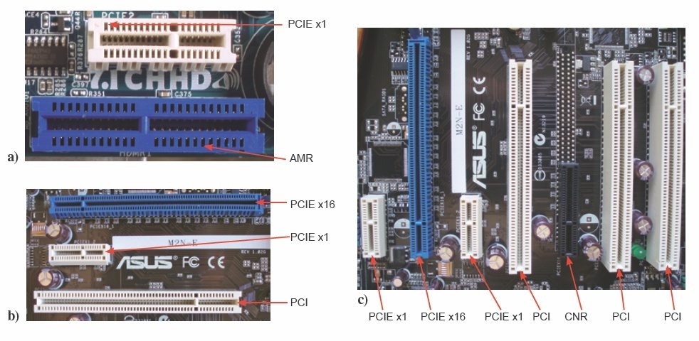Figure 11. Slots
Slots less common are:
- AMR: a small slot to connect audio devices
- CNR: AMR + network card.

Socket
The socket is the place of the motherboard where the processor is inserted. Each generation of processors have their sockets. Each is compatible only with the same family.
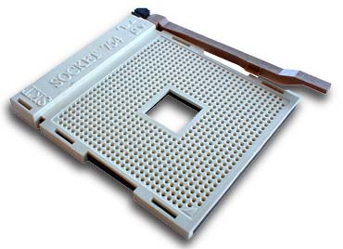Figure 12. ZIF socket
Today all the CPU sockets use the ZIF (Zero Insertion Force) mechanism. With this mechanism, the processor is inserted and removed without apply any pressure on him. Lifting the lever near the socket, the microprocessor is released, being extremely simple remove it.

Chipset
The chipset is the set of chips that are responsible for controlling certain functions of the computer, such as how the microprocessor interacts with the memory, the CPU, the ports PCI, USB, etc. Formerly, these functions were simple and chipset was the last item that was granted importance when buying a motherboard. Today the story has changed. Processors, memory and other components are more complex, and the chipset is the most important component of the motherboard.
Nowadays, the chipset consists of two chips: the Northbridge and Southbridge, although, in recent years, there is a trend to re-make the chipset again be a single chip.
Some chipset manufacturers: Intel, nVidia, SiS, Via ..

Northbridge
It is the most important motherboard integrated circuit. Its function is to control the high-speed components and its complexity is at the level of the CPU. Its work is very demanding because it have to control traffic between high speed buses and even, in some versions, incorporates a graphics controller.
 This requirement makes its temperature rises, so the latest models incorporate a sink and even a fan to help cooling.
The components that it controls are memories, CPU and graphic card. It's easy locate it. Its near this components.

Southbridge
It is sometimes called I/O Controller Hub. It is responsible for coordinating the input and output devices and low speed capabilities motherboard. It does not communicate directly with the CPU, but does so through the Northbridge.
The components that it controls are expansion slots (like PCI, AGP...), device connectors (like SATA, IDE, Ethernet,...) or peripheral ports (USB, FireWire, COM...).

Trade names
Although conceptually the chips are very similar among manufacturers, these use different trade names, looking for differentiation. For example:
- MCH o GMCH (intel): Northbridge with and without graphic controller
- IOH (intel): Northbridge without memory controller (in i3,i5,i7 the memory controller is inside CPU)
- SPP (nVidia): Northbridge
- ICH (intel): Southbridge
- MCP (nVidia): Southbridge

Northbridge – Southbridge connection
Although the Southbridge controls the slower components, they also have improved its performance in recent years and it was slow, it is not so much anymore. That is why not only the Southbridge has increased its complexity, but also the bus that communicates it with the Northbridge has improved considerably. Nowadays, motherboard manufacturers use the DMI bus (Intel), HyperTransport (nVidia) or V-Link (Via).

Block diagram
A chipset diagram block shows how to the chipset is connected with the different components of the motherboard. The example figure shows a Intel Core Duo (CPU) connection with a 945GSM Northbridge and 82801 Southbridge.
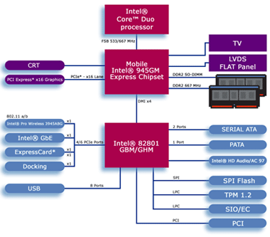Figure 13. Block diagram of a chipset connection

Processors
We could say that the processor is the brain of the computer. It is a chip that has within it thousands or millions of transistors. They usually have a shape of a square or rectangle and black can be found on an element called socket.

Internal architecture
Over time and with the advancement of technology, the scale of integration of components is increased (the number of transistors included in the processor is increasing, that is, they are becoming smaller).
Today, there are two kinds of processors: single and multi core.

Single Core
The architecture of the single core processors has been discussed on the unit about Computer Functional Elements.
- Control Unit: Responsible for seeking the instructions in the main memory and decode them to send control commands to other components.
- ALU. Arithmetic Logic Unit: responsible for performing arithmetic and logical operations.
- FPU. Float Point Unit: also called math coprocessor. It is responsible for performing floating-point operations. It usually performed addition and multiplication operations, although someone perform higher functions such as exponents.
- L1 cache or Level 1 cache: is a volatile memory built into the processor core operating at the same speed as this. Its function is to store the most common data for faster location.
- L2 cache or Level 2 cache: is a volatile memory built into the processor, although not directly in the heart of this. The purpose is the same as L1, but slower although bigger
- BSB: is the connection between the microprocessor and its L2 cache.
- FSB: is the data bus used as principal in some of Intel microprocessors (in AMD processor is called HyperTransport).
Cache
L1
Cache
L2
BSB
Cache
L2
FSB
UC
ULA
Bus de control

Figure 14. Single core diagram

Multi core
The current microprocessor manufacturing technology is reaching its limit. Each time smaller and faster processors are manufactured and that causes an increase in temperatures of the processors. In fact, today all processor have a (very) good cooling system.
These problems make it difficult to increase processor performance, so for future enhancements, it was necessary to find another way other than the increased speed.
The idea was increase the number of core. In a single core processor only one instruction can be processed in an instant, but if we have n cores the number of instructions to be processed in an instant will be n. Based on this kind of work, the parallel processing, the manufacturers began to build multicore processors.
The general struct is similar to single core processors, but we have to add:
- Integrated memory controller: the memory controller for faster access to RAM
- Bus transport high speed.
The figure shows a block diagram of a dual-core processor with independent L1 cache and L2 appears independent. Other times it may happen that the L2 cache is shared by both cores.
In general, they offer better response during multitasking. However, they increase the total heat to dissipate and need a high bus bandwidth.
Núcleo
1
Núcleo
2
Caché L1
Núcleo 1
Datos
Caché L1
Núcleo 1
Instrucciones
Caché L1
Núcleo 2
Instrucciones
Caché L1
Núcleo 2
Datos
Cache
L2

Cache
L2

Bus de transporte de alta velocidad
Controlador de memoria

Figure 15. Dual core diagram

Features

Frequency
Processors are devices that perform a big number of tasks in stages, so they need a way so that all the components work at the same rate, with the same rhythm. This is achieved with a clock signal whose frequency is called frequency microprocessor.
The frequency of a processor is measured in millions or billions of hertz, ie, the commonly used MHz or GHz units.
 The frequency has never been a very good parameter to assess the real speed (that received by a user) of a processor. It should only be used to compare processors of the same family: two Pentium IV, two i7 ..., which are identical in all other respects. This is because each processor can perform in a single cycle a number of very different work.

Bus speed
Processors have a data bus to communicate with other system elements. This bus is connected to the Northbridge, which communicates with memory or some expansion buses like PCIe. This bus is called FSB or Front Side Bus in Intel microprocessors and HyperTransport in AMD.
The transmission will be better if the flow rate is high.
- The first parameter affecting the flow rate is the width of the bus, that is, the number of bits that can be transmitted in each clock pulse. That width has grown from 8 to 64 bits.
- The second parameter is the clock speed at which the bus operates. Because of the difficulty to manufacture electronic components operating at processor speeds (MHz or GHz), the bus speed is usually lower than the processor (66MHz, 133MHz, 266MHz ...).
◻ The processor speed is set as a multiple of the bus speed.
Modern processors use buses with multiple use of the clock signal, so that for each clock pulse, it sends various data groups of bit and not just one. So we talk about a bus speed in MHz equivalent (which value is greater than real MHz) , because this MHz are not the real, but the user feels that the speed is greater. For example, in an Intel Core 2 that uses the clock signal to send 4 bit, its FSB is called FSB800 (although the bus runs at 200MHz physical), or FSB1333 (although it works 333 physical MHz).

Cache
A cache is a fast memory that is used to store a copy of the data most likely required, then accelerating performance by reducing the number of times to access the RAM (which is slower).
There are three kinds of processor cache:
- L1 cache: always internal, built into the kernel itself. it always runs at the same speed than processor. It is usually divided into two parts: data and instructions. Today is usually around 512 KB- 1MB.
- L2 and L3 cache: they are connected the BSB (faster than the FSB). They can be included in the micro core inside the encapsulated or external.
When the processor is looking for a piece of data, it look first in the L1, if it find it, it use it. otherwise it goes through levels to reach RAM.
In the nomenclatures, when 64KB + 64KB appears, it indicates that is 64 KB for data and the same size for instructions. If it appears 2 x 4MB, it indicates that are 4 MB per core (if two cores).

32 and 64 bits
Although, many years ago, some parts of the processors were 64-bit or more, most records were still 32 bits, allowing access to only 4 GB of RAM (2³²).
In the last years, AMD (first) and Intel (after) supplemented the x86 32-bit technology with 64-bit option, creating the x86-64 technology. In this technology, all 32-bits and 64-bits programs are supported. The addressing memory has increased, but not using the 64-bit but, for now, 44. That allows to address 2⁴⁴ = 16TB of memory.

Memory

Computer memory system
RAM memory has two main characteristics:
- RAM is used to store data temporarily, that is, until the computer shuts down or is restarted.
- Its access is random (in fact, RAM means Random Access Memory), that is, we can be accessed anywhere at any time.
We can imagine the memory like a big grid. To identify each cell we use the address of the cell, or, in other words, the memory address. In each cell, the memory can save one bit. To work in a easier way, the computer puts in groups of 2^{n}, with n>=3 n<=7. Each group is called word. The next figure shows an example of a memory of 4Kb (or 512B) with a word length of 8 bits:

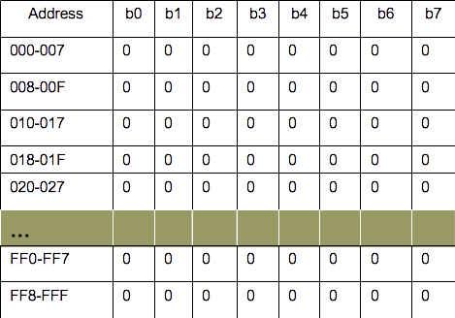Figure 16. 512B memory
◻ The amount of memory that a computer can access depends on the width of the address bus. The maximum number of memory addresses that a processor can access is 2n, where n Is the bus width.
Thus, in the x86 processor technology, the address bus has a width of 32 bits, that is, 2³² addresses or, which is, 2³² bytes = 4,294,967,296 bytes = 4GB. A processor with this technology may not take more than this amount of RAM.

Memory controller
It manages requests for data from memory performed by the microprocessor or other elements of the PC (DMA devices to be discussed later).
Historically, the memory controller was on the northbridge, however, nowadays there is a trend to integrate it within the microprocessor (for example in the i3, i5 or i7). This allows for faster memory access.

Bus memory
It is the path to the data. It is divided in two:
- Address Bus: It is in charge of sending the memory addresses. As discussed above, depending on its width, you can address a maximum amount of memory.
- Data Bus: the part that transmits data and instructions itself. Current processors use 64-bit buses, that is, can be transmitted 8 bytes in each clock cycle..
This bus has a speed, which is measure in Hz. The higher the speed of the bus more data can be sent. For instance, for a 32bits bus to 100MHz, the flow rate will be:

32*100*10⁶ b/s = 32*10⁸ b/s = 4*10⁸ B = 4*10⁸/2²⁰ MB/s= 381,47 MB/s

Features

Clock speed
Today in each memory the maximum clock speed that can reliably support indicated. Thus for example, a PC100 module (nomenclature for SDRAM), means that it is capable of supporting a 100 MHz bus.
However, today the speed indicated on the designation of memory usually not refer to the real bus speed, but it is the equivalent speed. For example, a DDR333 memory, works with a physical (real) bus of 166 MHz, but it sends information two times per each clock cycle (DDR, will be study later), which is equivalent to a bus of 333MHz but send information one time per each clock cycle.

Bandwidth
The goal is to get a memory that transmits the maximum amount of data. To represent this value we use the bandwidth, one of the fundamental parameters on the performance of a memory.
This is a mix between the clock speed and the bus width, and express the flow rate that the memory can achieve. Its value can be calculated by:
(real clock speed x use of cycle x bus width) / 8 = bytes/s.
For example, DDR-667 memory operates on 333MHz physical bus but with double use. Working on a 64-bit bus which is capable of transmitting 5333MB/s.

Number of channels
There is one more factor to consider: the number of channels. It really is not just a factor of memory, also of the MoBo in which you are connecting the memory. The memory controller can allow access to two channels simultaneously (or even three or four), which makes multiplying the effective bandwidth. This technologies are called dual, triple or quad channel.
To use Dual Channel, Triple Channel or Quad Channel requirements are usually: to have a good and identical (two to two in Dual, three to three in Triple or four to four in Quad Channel) memory modules that were DDR, DDR2, DDR3 (in the case of Triple Channel only DDR3) and install them in special slots memory following the instructions of MoBo's manufacturer.
In this case the way to calculate the bandwidth is:
(number of channels x real clock speed x use of cycle x bus width) / 8 = bytes/s.

RAM types
There are a lot of RAM types. To sum up, we are going to teach:
- SRAM. Static RAM. They are faster, but take up more size, have less capacity and are more expensive. Often they used as a cache.
- DRAM. Dynamic RAM. It is the usual type of RAM of our computers. It is slower than SRM, but cheaper and have more capacity. There are several kinds in function of its use of the cycle:
  - DDR: double use of the cycle
  - DDR2: quadruple use of the cycle
  - DDR3: they send 8 bits per cycle

Memory modules
The modules are rectangular printed circuit cards where the memory chips are soldered.

SIMM and DIMM modules
Single In Line Memory Module. The connection pins are in the same side of the card. To connect them we need to introduce them into the slot with a 45º angle and then, straightened until they are gripped by the side clips.
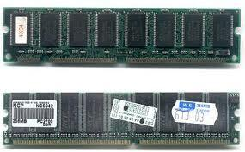Figure 17. SIMM modules
DIMM
Dual In Line Memory Module. Its very similar to the SIMM module, but physically it is bigger and they have contact pins in both sides.

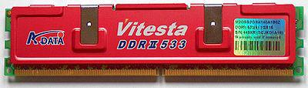Figure 18. DIMM with heat sink

Laptops modules
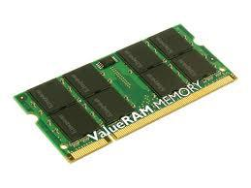Figure 19. SO DIMM Module
The memory modules for laptops are called SO-DIMM and are sized much smaller than the modules for PC.
There is also an even smaller size called MicroDIMM

Unbuffered and registered modules
When many chips are installed in a module or many modules on a computer, stability starts to get worse for electrical reasons. In some MoBo's, fill all available slots can force slow down the operating speed for stability.
To avoid this, registers or buffers are added to the modules that ensure stability at the expense of losing some performance. The registered modules are visually differentiated by having one or more chips more (sometimes a smaller size and horizontal).
These modules should only be used when they are necessary: they are more expensive, performance is lost and must be supported by controlled memory. The registered modules should not be mixed with unbuffered.

Parity modules and ECC modules
When the computer is used for critical tasks, we must ensure the integrity of the data memory or, at least, know if there have been failures to read or write.
Methods to achieve this include the application of a mathematical algorithm to the data and compare the result with the data to know if there is an error. There are two methods:
- Parity generates a bit that indicates whether an even or odd number of zeros (or ones) exists. Before sending the byte, the system check the byte and the parity bit to see if there are any changes. This has the problem that if failures occur in pairs, could pass as OK.
- ECC: error correction code. It allow detect and fix small errors (its functionality is beyond the list of topic for this course )
Both of them require more bits per byte, so visually there are more memory chips in each module. Moreover, error checking takes time, so the performance is lower.
It is rare to find a server that does not use ECC. The characteristics registered and ECC are independent, although in practice they almost always go together.

Additional material
[1] Glossary.
[2] Exercises.

Bibliography
[1] Sistemas Informáticos. Isabel Mª Jimenez Cumbreras. Garceta. 2012

[2] El PC: hardware y componentes (edición 2012). Juan Enrique Herrerías Rey , Anaya multimedia, 2012
[3] Windows 10 Modo UEFI. Instalación en modo de particiones MBR o GPT.

We will study the kinds of memories later
We will study the expansion cards later
The chipset manufacturer does not have to be the motherboard manufacturer or processor. Even each chip chipset is sometimes from a different manufacturer.
A transistor is a very simple but important electronic device. Its task is similar to a valve. It has three connectors. If we put electrical current in one of them the transistor, allows the current pass through the other connectors. Otherwise, the transistor will not allow pass.
A hertz measures the number of times that something occurs in a second,
We are assuming an 8-bit word
We will study later
How often it sends information per cycle?

